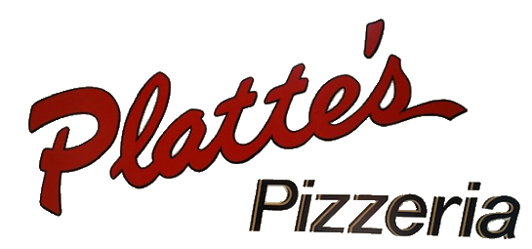
Rental of our banquet room up to 4 hours, with catering by Platte’s Pizzeria (menu options below).
Price: No room rental charge. $350 minimum purchase required. $100 Cancellation Fee if cancelled within 2 months of party.
Catering prices below apply.
Catering Menu Options:
Pizza - see regular menu for pricing and options
Lasagna - (feeds 24) - $120.00
Spaghetti with ground beef and Sausage (feeds 25) - $110.00
Chicken Alfredo - (feeds 20-25) - $120.00
Half Pan - $70.00
Without Chicken (full pan) - $95.00
Penne with Pasta Sauce and Meatballs (feeds 20-25) - $120.00
Half Pan - $70.00
Baked Chicken (feeds 20-25) - $110.00
BBQ Pulled Pork (feeds 25) - $100.00
Sloppy Joes (feeds 25) - $100.00
Taco Bar (hard and Soft tacos, nachos chips, and all the fixings for 25 people) $205.00
Macaroni and Cheese (20-25 people) - $70.00
Half pan - $40.00
Traditional Wings (40ct) with your choice of sauces - $75.00
Boneless Wings (40ct) with your choice of sauces - $45.00
Chicken Tenders (40ct) with your choice of sauces - $75.00

House or Caesar Salad (feeds 20-25) - $40.00
*Fruit Salad (Seasonal Fruit - 20-25 people) - $60.00*
Green Bean Casserole (20-25 people) $60.00
*Fresh Green Beans (20-25 people) - $55.00*
Mashed Potatoes (20-25 people) - $55.00
Redskin Potatoes (20-25 people) - $55.00
Cheesy Potatoes (20-25 people) - $65.00
Veggie Tray with Dip - $45.00
Bread sticks / dozen - $7.50
Pirate Bites - $7.50
Sweet Pirate Bites - $8.25
Variety of Cookies (25 people) - $35

*Prices may vary based on season*

Beverages: All alcohol and other beverages must be purchased through Platte’s. No outside beverages will be permitted.
Decorations: No glitter or confetti allowed. No open flames. No tape on any painted walls
Important: Final menu decisions and number of guests are required no later than 10 days prior to your event

Prices show cash price do not include taxes or card fees and are subject to change without notification.
If party exceeds 15 people we require a pre-order and individual orders are no longer allowed.
To View All Rules and Terms please refer to our website under our banquet tab

